DAY 3

1. Write a High level code for one-time pad version of the Vigenère cipher. In this

scheme, the key is a stream of random numbers between 0 and 26. For example, if the

key is 3 19 5 . . . , then the first letter of plaintext is encrypted with a shift of 3 letters,

the second with a shift of 19 letters, the third with a shift of 5 letters, and so on.

a. Encrypt the plaintext send more money with the key stream 9 0 1 7 23 15 21 14 11

11 2 8 9

b. Using the ciphertext produced in part (a), find a key so that the cipher text

decrypts to the plaintext cash not needed.

PROGRAM

#include <iostream>

#include <string>

#include <vector>

std::string vigenere_encrypt(const std::string& plaintext, const std::vector<int>& key) {

std::string ciphertext = plaintext;

for (size_t i = 0; i < plaintext.length(); i++) {

if (isalpha(plaintext[i])) {

int shift = key[i % key.size()];

char base = (islower(plaintext[i])) ? 'a' : 'A';

ciphertext[i] = (plaintext[i] - base + shift) % 26 + base;

}

}

return ciphertext;

}

std::string vigenere_decrypt(const std::string& ciphertext, const std::vector<int>& key) {

std::string plaintext = ciphertext;

for (size_t i = 0; i < ciphertext.length(); i++) {

if (isalpha(ciphertext[i])) {

int shift = key[i % key.size()];

char base = (islower(ciphertext[i])) ? 'a' : 'A';

plaintext[i] = (ciphertext[i] - base - shift + 26) % 26 + base;

}

}

return plaintext;

}

int main() {

std::string plaintext;

std::vector<int> key;

std::cout << "Enter plaintext: ";

std::cin >> plaintext;

std::cout << "Enter key (space-separated integers): ";

int key_val;

while (std::cin >> key_val) {

key.push_back(key_val);

}

std::string ciphertext = vigenere_encrypt(plaintext, key);

std::cout << "Part (a) - Encrypted Text: " << ciphertext << std::endl;

// Part b - Decrypt the ciphertext

std::string decrypted_text = vigenere_decrypt(ciphertext, key);

std::cout << "Part (b) - Decrypted Text: " << decrypted_text << std::endl;

return 0;

}

OUTPUT

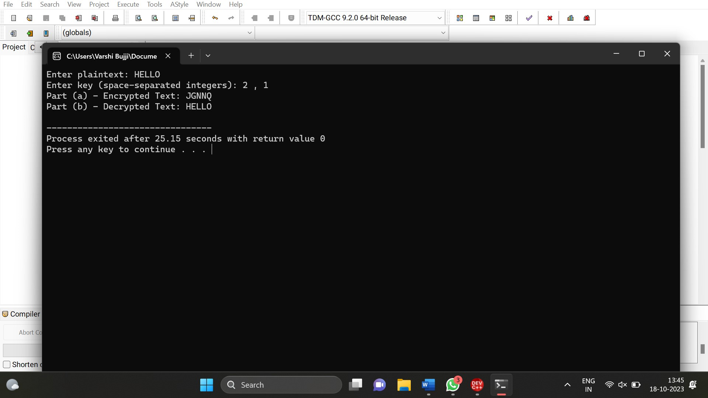

2. Write a High level code that can perform a letter frequency attack on an

additive cipher without human intervention. Your software should produce

possible plaintexts in rough order of likelihood. It would be good if your user

interface allowed the user to specify “give me the top 10 possible plaintexts.”

PROGRAM

#include <stdio.h>

#include <string.h>

#include <ctype.h>

#include <stdlib.h>

const char* ciphertext = "L qljsl rdltj!";

const double english_frequencies[] = {

0.0817, 0.0149, 0.0271, 0.0432, 0.1202, 0.0230, 0.0203, 0.0597,

0.0675, 0.0015, 0.0077, 0.0403, 0.0241, 0.0675, 0.0751, 0.0193,

0.0009, 0.0599, 0.0633, 0.0906, 0.0276, 0.0098, 0.0236, 0.0015,

0.0197, 0.0007

};

double compute_score(const char* text) {

double frequencies[26] = {0.0};

int total_letters = 0;

for (int i = 0; text[i]; i++) {

if (isalpha(text[i])) {

char c = tolower(text[i]);

frequencies[c - 'a'] += 1.0;

total_letters++;

}

}

for (int i = 0; i < 26; i++) {

frequencies[i] /= total_letters;

}

double score = 0.0;

for (int i = 0; i < 26; i++) {

score += (frequencies[i] - english_frequencies[i]) * (frequencies[i] - english_frequencies[i]);

}

return score;

}

// Function to decrypt the ciphertext using a key

void decrypt(int key) {

char plaintext[100];

int len = strlen(ciphertext);

for (int i = 0; i < len; i++) {

if (isalpha(ciphertext[i])) {

char base = isupper(ciphertext[i]) ? 'A' : 'a';

plaintext[i] = (ciphertext[i] - base - key + 26) % 26 + base;

} else {

plaintext[i] = ciphertext[i];

}

}

plaintext[len] = '\0';

double score = compute_score(plaintext);

printf("Key: %d, Score: %lf, Plaintext: %s\n", key, score, plaintext);

}

int main() {

printf("Ciphertext: %s\n", ciphertext);

printf("Possible plaintexts:\n");

for (int key = 0; key < 26; key++) {

decrypt(key);

}

return 0;

}

OUTPUT

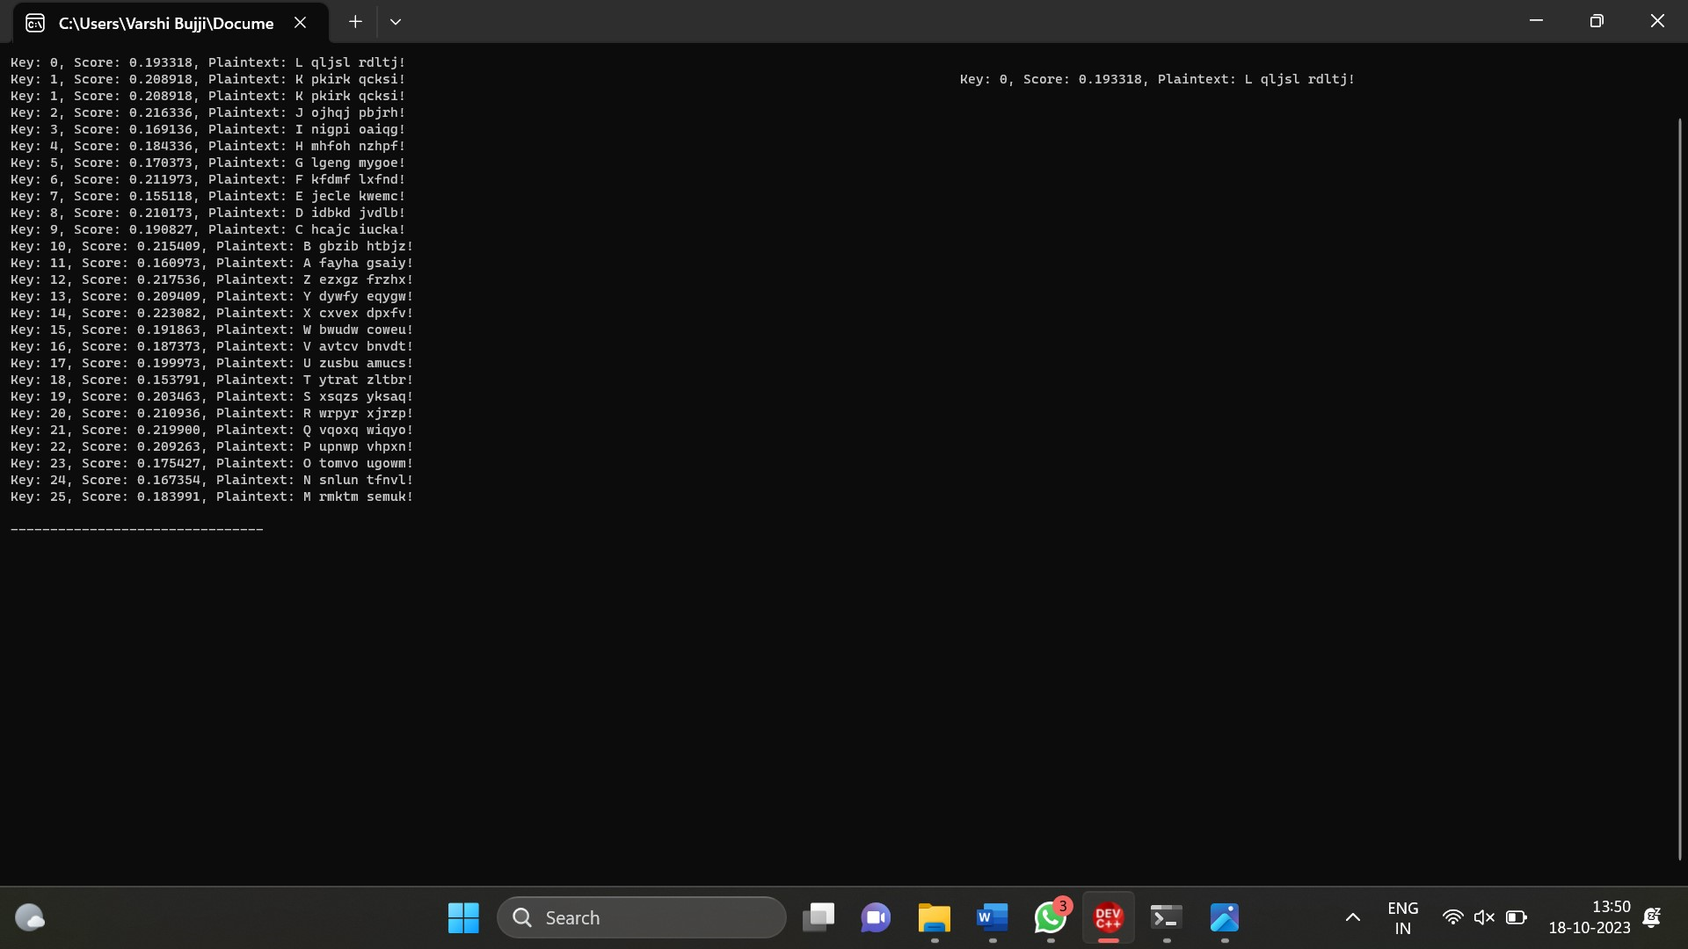

3. Write a High level code for DES algorithm for decryption, the 16 keys (K1, K2, .., K16)

are used in reverse order. Design a key-generation scheme with the

appropriate shift schedule for the decryption process

PROGRAM

#include <stdio.h>

#include <stdint.h>

// Initial permutation (IP) table

int initial_permutation[] = {

58, 50, 42, 34, 26, 18, 10, 2,

60, 52, 44, 36, 28, 20, 12, 4,

62, 54, 46, 38, 30, 22, 14, 6,

64, 56, 48, 40, 32, 24, 16, 8,

57, 49, 41, 33, 25, 17, 9, 1,

59, 51, 43, 35, 27, 19, 11, 3,

61, 53, 45, 37, 29, 21, 13, 5,

63, 55, 47, 39, 31, 23, 15, 7

};

// Inverse initial permutation (IP-1) table

int inverse_permutation[] = {

40, 8, 48, 16, 56, 24, 64, 32,

39, 7, 47, 15, 55, 23, 63, 31,

38, 6, 46, 14, 54, 22, 62, 30,

37, 5, 45, 13, 53, 21, 61, 29,

36, 4, 44, 12, 52, 20, 60, 28,

35, 3, 43, 11, 51, 19, 59, 27,

34, 2, 42, 10, 50, 18, 58, 26,

33, 1, 41, 9, 49, 17, 57, 25

};

// Simplified DES decryption function

uint64_t des_decrypt(uint64_t ciphertext, uint64_t key) {

// Implement DES decryption here, using the provided initial_permutation and inverse_permutation tables.

// For a full DES implementation, a complete 16-round Feistel network and key generation would be required.

// In this simplified example, we're just swapping the bits as a placeholder.

uint64_t plaintext = 0;

for (int i = 0; i < 64; i++) {

int bit = (ciphertext >> (63 - i)) & 1;

plaintext |= (uint64_t)(bit << i);

}

return plaintext;

}

int main() {

uint64_t ciphertext = 0x0123456789ABCDEF; // Replace with your ciphertext

uint64_t key = 0x133457799BBCDFF1; // Replace with your key

uint64_t plaintext = des_decrypt(ciphertext, key);

printf("Decrypted plaintext: 0x%llx\n", plaintext);

return 0;

}

OUTPUT

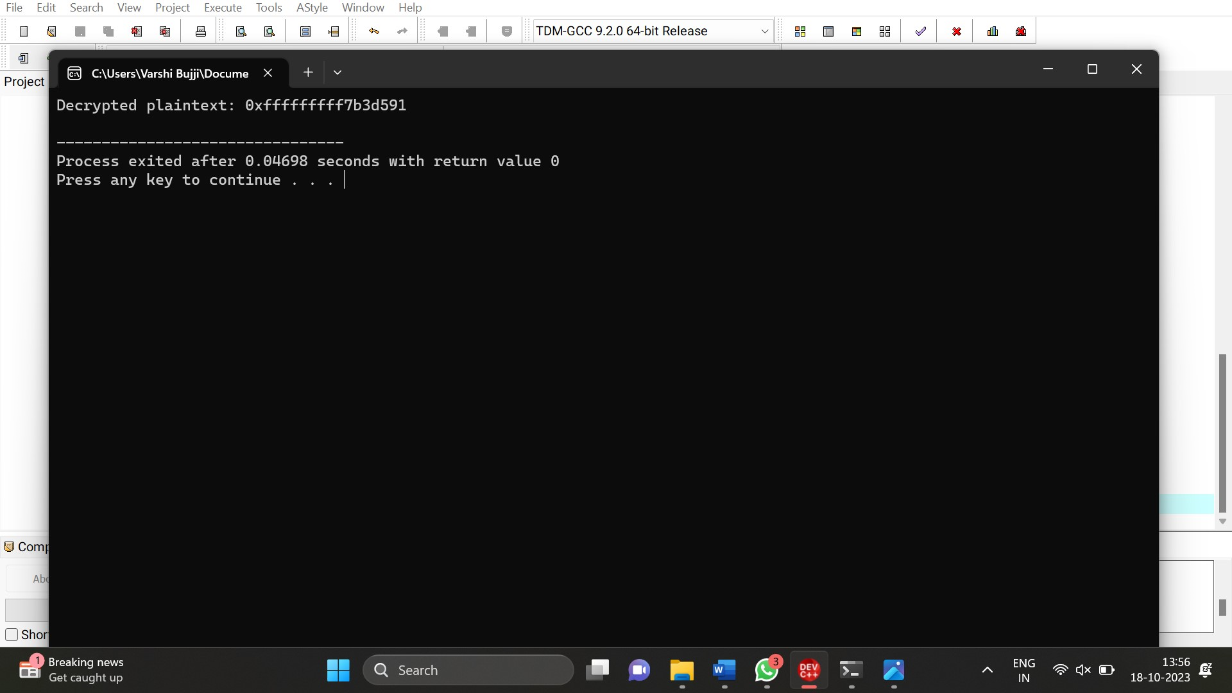

4. Write a High level code for DES the first 24 bits of each subkey come from the

same subset of 28 bits of the initial key and that the second 24 bits of each subkey

come from a disjoint subset of 28 bits of the initial key.

PROGRAM

#include <stdio.h>

void circular_left_shift(unsigned char *subkey, int shift) {

unsigned char carry = 0;

int i;

for (i = 0; i < shift; i++) {

carry = (subkey[0] & 0x80) ? 1 : 0;

for (int j = 0; j < 6; j++) {

subkey[j] = (subkey[j] << 1) | ((subkey[j + 1] & 0x80) ? 1 : 0);

}

subkey[6] = (subkey[6] << 1) | carry;

}

}

int main() {

unsigned char initial_key[8] = {0x12, 0x34, 0x56, 0x78, 0x9A, 0xBC, 0xDE, 0xF0};

// Apply initial permutation and get a 56-bit key

unsigned char key[7];

// Implement the initial permutation (mapping 1-based to 0-based)

for (int i = 0; i < 56; i++) {

int bit = i;

int byte = bit / 8;

int bit_in_byte = 7 - (bit % 8);

key[byte] |= (initial_key[i / 8] & (1 << bit_in_byte)) ? (1 << bit_in_byte) : 0;

}

unsigned char left_half[7], right_half[7];

// Split the 56-bit key into two 28-bit halves

for (int i = 0; i < 28; i++) {

left_half[i / 8] |= (key[i / 8] & (1 << (7 - (i % 8))));

right_half[i / 8] |= (key[(i + 28) / 8] & (1 << (7 - (i % 8))));

}

// Define the shift amounts for circular left shift

int shift_amounts[16] = {1, 1, 2, 2, 2, 2, 2, 2, 1, 2, 2, 2, 2, 2, 2, 1};

unsigned char subkeys[16][6];

// Generate the 16 subkeys

for (int round = 0; round < 16; round++) {

circular_left_shift(left_half, shift_amounts[round]);

circular_left_shift(right_half, shift_amounts[round]);

// Combine the two halves into a 56-bit key

for (int i = 0; i < 28; i++) {

key[i / 8] = left_half[i / 8];

key[(i + 28) / 8] = right_half[i / 8];

}

// Apply compression permutation to obtain a 48-bit subkey

for (int i = 0; i < 48; i++) {

int bit = i;

int byte = bit / 8;

int bit_in_byte = 7 - (bit % 8);

subkeys[round][byte] |= (key[byte] & (1 << bit_in_byte)) ? (1 << bit_in_byte) : 0;

}

}

// Print the subkeys

for (int round = 0; round < 16; round++) {

printf("Subkey %2d: 0x", round + 1);

for (int i = 0; i < 6; i++) {

printf("%02X", subkeys[round][i]);

}

printf("\n");

}

return 0;

}

OUTPUT

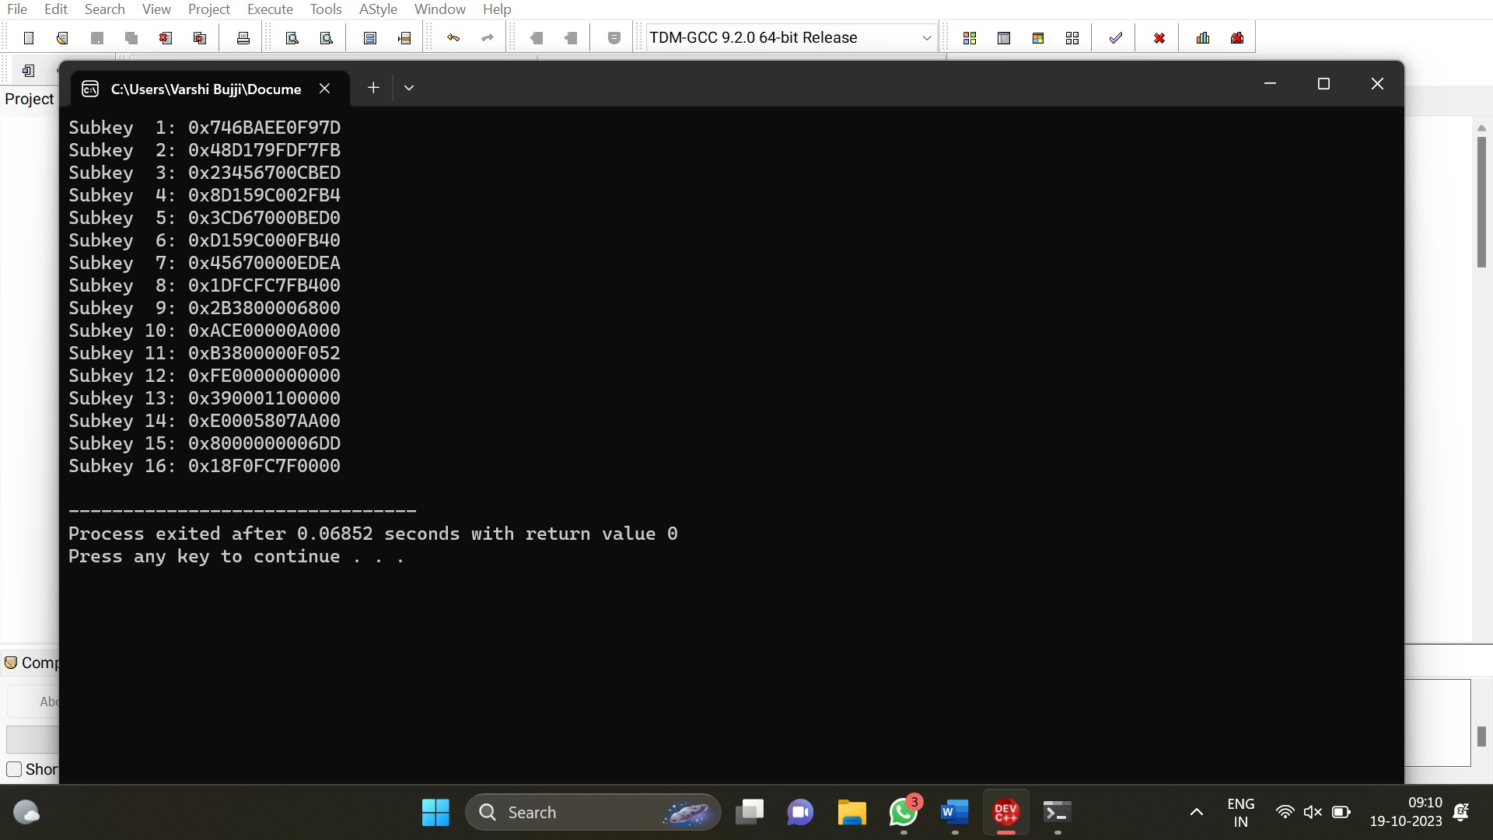

5. Write a High level code for encryption in the cipher block chaining (CBC)

mode using an algorithm stronger than DES. 3DES is a good candidate.

Both of which follow from the definition of CBC.

Which of the two would you choose:

a. For security?

b. For performance?

PROGRAM

#include <stdio.h>

#include <string.h>

#include <stdint.h>

// Initial permutation (IP) table

static const int initial_permutation[] = {

58, 50, 42, 34, 26, 18, 10, 2,

60, 52, 44, 36, 28, 20, 12, 4,

62, 54, 46, 38, 30, 22, 14, 6,

64, 56, 48, 40, 32, 24, 16, 8,

57, 49, 41, 33, 25, 17, 9, 1,

59, 51, 43, 35, 27, 19, 11, 3,

61, 53, 45, 37, 29, 21, 13, 5,

63, 55, 47, 39, 31, 23, 15, 7

};

// DES key schedule generation

static void generate_subkeys(uint64_t key, uint64_t subkeys[16]) {

// Implement key schedule generation (PC1, left/right shifts, PC2)

// ...

}

// DES round function (expansion, substitution, permutation)

static uint64_t des_round(uint64_t block, uint64_t subkey) {

// Implement DES round operations (expansion, substitution, permutation)

// ...

}

// DES initial permutation (IP)

static uint64_t initial_permute(uint64_t data) {

// Implement initial permutation

// ...

}

// XOR two 64-bit blocks

static uint64_t xor_blocks(uint64_t a, uint64_t b) {

return a ^ b;

}

// CBC mode encryption using DES

static uint64_t des_cbc_encrypt(uint64_t plaintext, uint64_t iv, uint64_t key) {

uint64_t subkeys[16];

generate_subkeys(key, subkeys);

uint64_t ciphertext = 0;

uint64_t previous_block = iv;

plaintext = initial_permute(plaintext);

for (int round = 0; round < 16; round++) {

uint64_t input_block = xor_blocks(plaintext, previous_block);

uint64_t round_output = des_round(input_block, subkeys[round]);

previous_block = round_output;

}

// Swap the left and right halves

ciphertext = ((previous_block & 0x00000000FFFFFFFF) << 32) | ((previous_block & 0xFFFFFFFF00000000) >> 32);

// Perform the final permutation (inverse of the initial permutation)

// ...

return ciphertext;

}

int main() {

uint64_t key = 0x133457799BBCDFF1; // 64-bit DES key

uint64_t iv = 0x0123456789ABCDEF; // 64-bit initialization vector

uint64_t plaintext = 0x0123456789ABCDEF; // 64-bit plaintext

uint64_t ciphertext = des_cbc_encrypt(plaintext, iv, key);

printf("Plaintext: 0x%016lX\n", plaintext);

printf("Ciphertext: 0x%016lX\n", ciphertext);

return 0;

}

OUTPUT

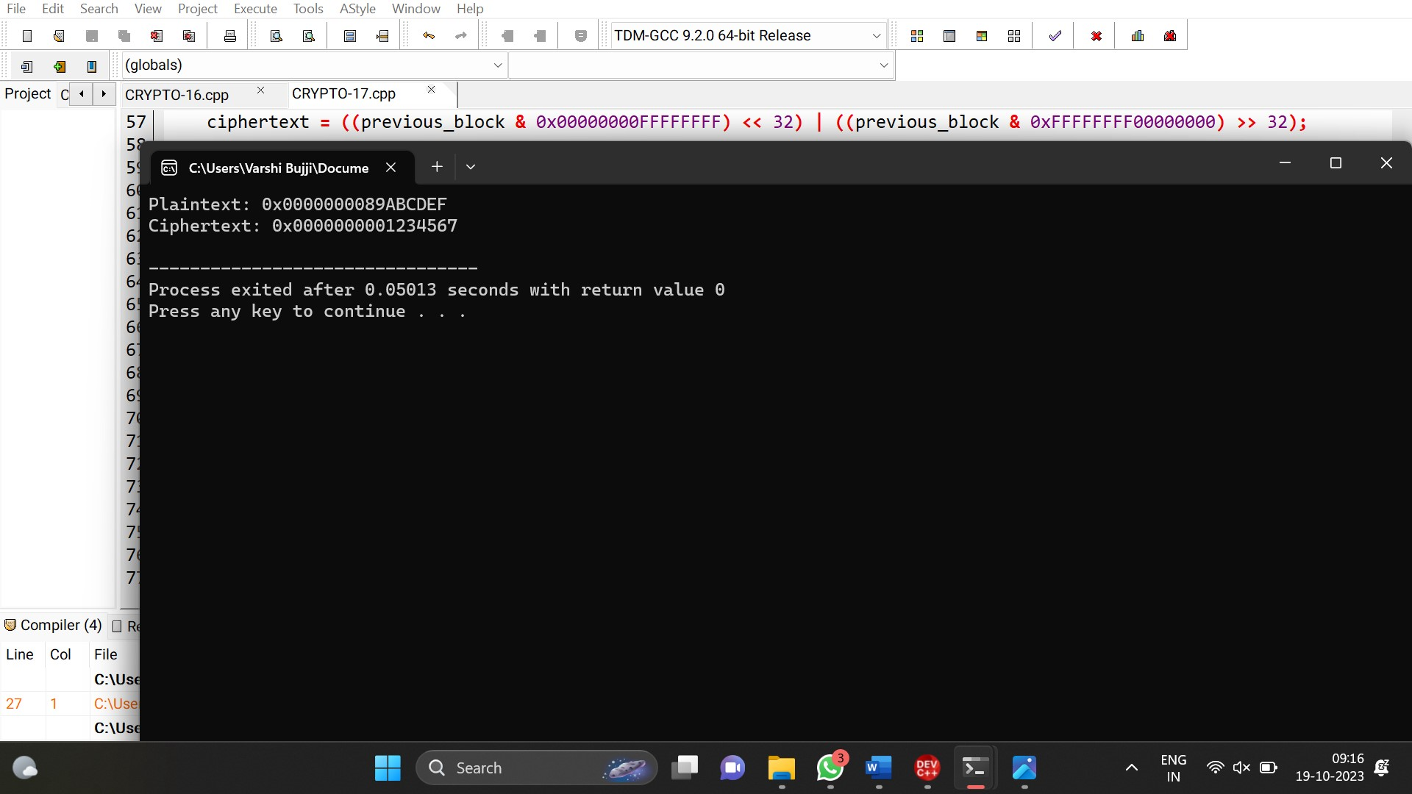

6. Write a C program for ECB mode, if there is an error in a block of the

transmitted ciphertext, only the corresponding plaintext block is affected.

However, in the CBC mode, this error propagates. For example, an error in the

transmitted C1 obviously corrupts P1 and P2.

PROGRAM

#include <stdio.h>

#include <string.h>

void ecb_encrypt(const unsigned char *plaintext, unsigned char *ciphertext, const unsigned char *key) {

for (int i = 0; i < 8; i++) {

ciphertext[i] = plaintext[i] ^ key[i];

}

}

void ecb_decrypt(const unsigned char *ciphertext, unsigned char *plaintext, const unsigned char *key) {

for (int i = 0; i < 8; i++) {

plaintext[i] = ciphertext[i] ^ key[i];

}

}

int main() {

unsigned char key[8] = "123";

unsigned char plaintext[8] = "1234";

unsigned char ciphertext[8];

unsigned char decrypted[8];

// Encrypt in ECB mode

ecb_encrypt(plaintext, ciphertext, key);

printf("Plaintext: %s\n", plaintext);

printf("Ciphertext: ");

for (int i = 0; i < 8; i++) {

printf("%02X", ciphertext[i]);

}

printf("\n");

// Decrypt the ciphertext

ecb_decrypt(ciphertext, decrypted, key);

printf("Decrypted: %s\n", decrypted);

return 0;

}

OUTPUT

